USS CONCORD NEWSLETTER, WINTER 2019

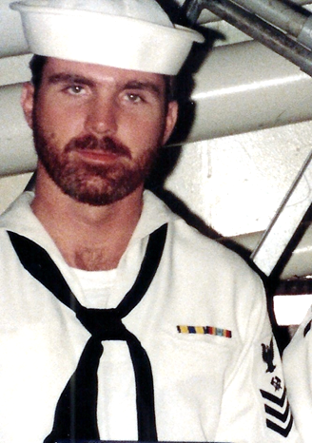

Ahoy
By Vice President \ Web Dude
Shipmates \ Families, as the calendar rolls into yet another year I’m hopeful that 2019 will bring many things to be thankful for in our lives. As you’re surely aware, the 2018 ships reunion was “hurricane’d out” so thankfully we will get a do over in a few months. It was refreshing however to see dedication from Steve and Sandy Lampp who decided to celebrate anyway and put together a mini celebration for our ship, more on that below. Hope Santa was good to you but if he left your stocking empty, gift yourself a Charleston vacation in March and a banquet dinner with your old shipmates.

Topics for this newsletter are as follows:
Article One: Membership status.
Article Two: Reunion 2018/19
Article Three: Sandy and Steve Lampp’s ship celebration
Article Four: Member Spotlight
Article Five: Taps
Article One
Association membership remains strong. As of this letter we currently have 153 active members on our muster. That said, 56 members dues will expire December 31st. To be safe, please renew using the link below. If you need confirmation of dues expiration, email our Secretary at garrysea@gmail.com.
We welcome new members to our organization and remind all that we are non-profit and all our proceeds go toward club functions such as our reunion event. Membership is required for those who wish to attend our reunions, but that’s not the only reason to join. By joining or renewing you’ll stay up-to-date on all association happenings (by the way it’s still only $20 bucks for two years), and gain access to the members only hatch page, which also permits access to the “members only” message board at our site. You can join or renew online here: http://www.ussconcord.org/id29.html
Welcome aboard to the following shipmates who either renewed or signed up for the first time in our club since our Summer Newsletter release: Ben Ellis (BT3 68-71) Dennis Dee (ADR-3 (HC-6/Det-86 70-71), Tom Weber (BT2 85-90), Chris Ebert (LTJG 74-76), Dan Ford Jr. (PN1 02-03), Neil Westgate (BT2 70-73), John Schuchter (SK3 70-72).
Article Two
Reunion 2018 /19. As I’m sure you’re aware, reunion 2018 was called off due to an unexpected hurricane but has been rescheduled for March 13, 2019. Our banquet will be held on Saturday night the 16th, at the same hotel as previously planned. Tours to choose from are, Tour #1 Patriots Point / Fort Sumter $97 (Includes transportation, admission, lunch) and Tour #2 Charleston Tea Plantation / Market Square / Carriage Ride $75 or $105 with Carriage Ride (includes transportation, admission, private guide, box lunch). Reservations must be made prior to February 13th to guarantee space and rate. Our 2020 reunion will stay on track and we can decide its location at our March 2019 business meeting. Visit www.acompletereunion.com/uss-concord, or our site www.ussconcord.org/id160.html to sign up.

Article Three
Sandy & Steve’s 50th Concord celebration: After it was confirmed that the hurricane would cancel our much anticipated 50th reunion, The Lampp’s decided to celebrate regardless. Sandy announced on FB that they would be at the Best Western in Daytona and invited any and all that wished to join them as they honored our ship with a toast on November 27th. Several of our shipmates answered the call and made the journey. I ask Sandy to send me photos and details of their event for a future story at our concord.org website. She was kind enough to offer some great shots and details, and I will run them in a couple weeks as our Winter quarter “spotlighted member”. Thanks Sandy and Steve.
Article Four
Our association identifies various members throughout the year and share their memories and pictures while they served aboard. This quarter BMC Darrell Lewis was chosen for the Fall quarter and his memories are available at our ussconcord.org website, “Member spotlight” page.

Spot lighted member
BMC Darrell Lewis 90-92

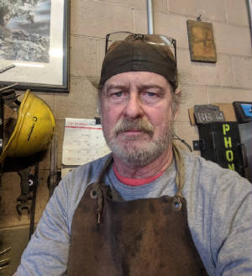

Article Five
The following shipmates have been reported as loss during this newsletter period: Jack Murphy jr. E-3 77-78, James Orr DP2 68-72.
If you have news of a member who has passed and has not been recognized as eternally departed at our website, please contact the webmaster at ussconcord.org.

Final Thoughts: As mentioned earlier in this letter, Sandy Lampp is a key player in our association and helps to keep our ship’s memory forefront and alive. As the sailors who actually went to sea we often forget about the sacrifices our families made so we could do our jobs. Even today as the ship is long gone, many of us still have family supporting our cause and mission in keeping our association alive and strong. Let’s give a special thanks to all those who made our time aboard possible and some who are still leading the cause into 2019. Well done / thanks!

See you in March,

Web Dude
HT1 82-86

