USS CONCORD WINTER 2018 NEWSLETTER

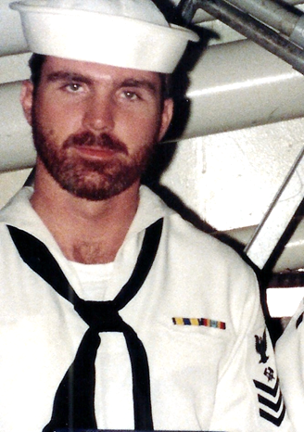

Ahoy
By Vice President \ Web Dude

Shipmates’ \ Families, as I cruise into 2018 I am once again reminded how quickly time flies. It seems like only yesterday we we’re preparing to assemble our first AFS5 reunion and the excitement of seeing old shipmates once again. Fast forward eight years and we are on the cuff of our 5th biennial reunion and the monumental 50th anniversary of Concords commissioning. If you have never attended one of these events I highly recommend placing it on your 2018 itinerary. We had a huge turnout in Norfolk (2016) and everyone had a great time! Special thanks to all our loyal members who’ve stayed with us throughout the years, and a big welcome to those who joined in 2017.

Topics for this newsletter are as follows:
Article One: Membership status.
Article Two: New “Hatch” Password
Article Three: Reunion 2018
Article Four: Member Spotlight
Article Five: Taps

Article One
Association membership remains strong with many of our original members continuing their involvement as well as many new members signing up this year. As of this letter we currently have 153 active members on our muster, however many memberships have expired as of year-end 2017!

Here is the list of our shipmates whose memberships are ending: Stephen Anderson, James Beindorf, Don Bissett Jr, George Campbell, Rick Cline, Silas Dalrymaple, Larry Dickey, Scott Eckhart, William Furlong, James Hundley, Frederick Keith, John Lendman, Wes Linscott, Carlos Mize, Richard Mueller, Mike Neeser, Harry Noel, Demar Palencia, Chris Parente, John Regina, Tom Robey, John Schuchter, Steven Severance, Robert Sharp, George Trbovich, Bob VanDeveer, Ronald Weston.
We encourage you to “re-enlist” so we can keep our membership base solid! We welcome new members to our organization and remind all that we are non-profit and all our proceeds go toward club functions such as our reunions. Membership is required for those who wish to attend our reunion events, but that’s not the only reason to join. By joining or renewing you’ll stay up-to-date on all association happenings (by the way it’s still only 10 bucks per year to join). You can renew online here: http://www.ussconcord.org/id29.html

Welcome aboard to the following shipmates who either renewed or signed up for the first time in our club since our Fall Newsletter release: Steve Larsen (DP2 68-70), Michael Shepperd (LT 78-81), Thomas Cote (IC2 74-77), James Pridgen "plank owner" (RD2 68 - 70), Matthew Arnold (MS3 89-92), Mike Hangelia (ET2 85-90), James Joiner (82 - 84), Frank Korzeniewski (RM3 72 - 740, John Califano (SK3 68-70), Darrell Pauley (SK3 72-75), Primo Magpantay (SK3 69 – 70), SKCM (90 - 91), Straud Britt (BT3 68-7O), Buck Slater (YN3 72-75).
Hopefully if you're still not a member, you’ll decide soon to add your name to our coveted sailing list!

Article Two
The “Hatch” page at our website provides pertinent information for our members in good standing. As webmaster, I receive occasional request from Concord sailors wishing to reconnect with members who served during “their time” aboard. I direct active members to the “Hatch”, and those who are still on the fence about joining are advised to join, and enter the “Hatch” to reunite with their shipmates. The “Hatch” is a “members only” benefit and as such must be controlled in accordance with our active member annual data base. Keeping with “Hatch” security we will be changing the password for entry in February. Active members will be emailed the new password for 2018. If your membership is due as of this letter you may wish to renew now to ensure delivery of the new password for this year.

Article Three
On Wednesday, 27 November 1968, USS Concord was commissioned at Long Beach Naval Shipyard. Fifty years later we will celebrate this event by presenting Concords 50th anniversary reunion in Charleston SC. Once again, we reached out to “A Complete Reunion” the party planners who have produced great reunion events in the past. ACR found us a great deal at the Crowne Plaza hotel and got us free breakfast for 2 thrown in with our room. This is a great hotel, convenient to the airport, and literally walking distance to Tanger Mall. Reunion dates are 12–16 September, 2018. The hotel is standing by to accept your reservation, reserve your room now. Tour selection and the banquet meal signup can be accomplished by visiting ussconcord.org, download the reunion brochure, and print and submit pages 7&8. Page 7 guarantees you a “50th” shirt (that fits), and page 8 lets you select your meal and the tours you wish to take. The price of all tours will include a driver, gratuities, and a meal *on some tours* so this is a good deal. Each tour “must have” 35 members signed up to take place.

Article Four
Our association identifies various members throughout the year and shares their memories and pictures while serving aboard. Petty Officer Roach was chosen as our “spotlighted” member for the Fall quarter and his memories are available at our website, “Member spotlight” page.

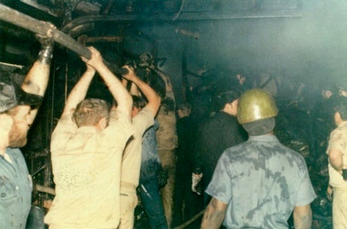
GMG3 Roach (77-81), served aboard USS Concord during her greatest casualty, the fire in Palma, the summer of 1978. I reached out to Petty Officer Roach in researching this event and as such, he was chosen this quarter as our spotlighted member to give us a look at those amazing days of USS Concord's life. Read Roach’s' input at the "Spotlighted Member" page at ussconcord.org.

Article Five

Taps. The following shipmates have been reported as loss during this newsletter period: IC2 Edward Peacock (70-73), OS3 Keith Barksdale, Steven L. Cottrell (76-78), EW3 Rodney Gossert, Captain Merril C. Pinkepank (2nd CO, 70-71), Captain Van F. Westfall (9th CO, 80-82).
If you have news of a member who has passed and has not been recognized as eternally departed at our website, please contact the webmaster at ussconcord.org.

Final Thoughts:

While I was preparing to honor Captain Westfall at our website I read the comments posted at his obituary page. It had the usual information e.g. family history, places he lived and career achievements, but his final request for those who knew him was special. “Van would like you to charge your glass and toast to him and the good times you had together. In his memory, love one another. Always remember to pay it forward”. I propose that we honor our skipper at the next reunion with his request! Hope you will join us,

r,
Web Dude

