USS CONCORD NEWSLETTER, SUMMER 2018

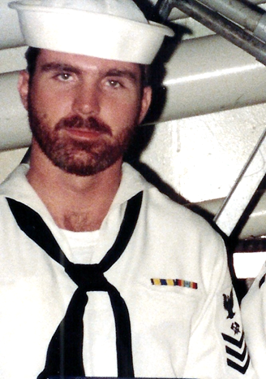

Ahoy
By Vice President \ Web Dude

Shipmates \ Families, in a few short weeks we will gather in Charleston, S.C. for our 5th biennial ships’ reunion. Many of you have signed up and made plans to attend (see our “who’s coming” list available at our website). If you’re still “on the fence” I recommend you at least consider attending. Believe it or not our next reunion event will be in 2020, wow. Gather up your sea stories, contact your old shipmates and let’s make the 2018 reunion our best one yet!

Topics for this newsletter are as follows:
Article One: Membership status.
Article Two: Reunion 2018
Article Three: Business Meeting.
Article Four: Members only “Hatch” (message board)
Article Five: Member Spotlight
Article Six: Taps

Article One
Association membership remains strong with many of our original members continuing their involvement as well as many new members signing up this year. As of this letter we currently have 139 active members on our muster. We welcome new members to our organization and remind all that we are non-profit and all our proceeds go toward club functions such as our reunion event. Membership is required for those who wish to attend our reunions, but that’s not the only reason to join. By joining or renewing you’ll stay up-to-date on all association happenings (by the way it’s still only 10 bucks per year to join), and gain access to the members only hatch page, which also permits access to the “members only” message board at our site. You can join or renew online here: http://www.ussconcord.org/id29.html

Welcome aboard to the following shipmates who either renewed or signed up for the first time in our club since our Spring Newsletter release: Joe Rutland (LCDR 84-87), Guy Columbro (RM3 75-77), Greg Crismon (LCDR 83-86), Roy “Skip” Richards (BT2 74-77), Stephen Anderson (RM2 68-72), Charles Nance (BM2 80-85), Christopher Parente (LT 79-82), Larry Murphy (LCDR 82-84), William Furlong (EN2 71-73).

Article Two
On Wednesday, 27 November 1968, USS Concord was commissioned at Long Beach Naval Shipyard. Fifty years later we celebrate this event by presenting Concords 50th anniversary reunion in Charleston SC. Once again, we reached out to “A Complete Reunion” the party planners who have produced great reunion events in the past. ACR found us a great deal at the Crowne Plaza hotel and got us free breakfast for 2 thrown in with our room. This is a great hotel, convenient to the airport, and literally walking distance to Tanger Mall, and a short ride to downtown “old Charleston”. Reunion dates are 12–16 September, 2018. The hotel is standing by to accept your reservation. Reservation activity has been high and the hotel has agreed to add another block of rooms to accommodate our event. They will continue to add rooms as long as they are available. It’s time now to make your tour selections and banquet meal signup. Visit ussconcord.org, download the reunion brochure, and print and submit pages 7&8. Page 7 guarantees you a “50th” shirt (that fits), and page 8 lets you select your meal and the tours you wish to take. The price of all tours will include a driver, gratuities, and a meal *on some tours* so this is a good deal. Each tour “must have” 35 members signed up to take place.

Article Three
Our Business Meeting is one of the highlights conducted during our biennial reunions. Most of us, who have attended reunions in the past, are aware of the productivity accomplished during these gatherings not to mention the comaraderie. Our business meeting will commence on Friday evening after tour # 3 @ approximately 3:00 PM. All Concord members, (excluding auxiliary members), in good standing are encouraged to attend. The meeting is conducted by our Association president and any old and new business that has come up during the past two years is addressed. Members will hear our treasurers report, membership activity, ship’s store news, and officer election for the coming two years, etc. Perhaps the most interesting topic is where to conduct future (the next) reunion location. Anyone can have input as to where they would like to see the event held. All participant input is heard and discussed with the group. If you would like to recommend a city for the next reunion, please come prepared to present your idea with information about your recommended city. Things to do, places to see, etc.. Reunion choices are usually narrowed down to three locations and often the member who nominates a preferred location also agrees to assist with hosting the event in their area, “it’s not that hard, organizers do most of the work”. Aside from business discussion, the BM is just a good way to re-connect, discuss the future of our organization and an excellent pre-mingle in preparation for the main event, our banquet. I highly recommend you add this to your reunion schedule of events.

Article Four
The “Hatch page” at our website is a member only benefit that regular readers of our newsletter are probably aware of. Did you know, however, that within the Hatch page is also a private “members only message board” reserved exclusively for our card-carrying shipmates? Why not give it a try?

Article Five
Our association identifies various members throughout the year and shares their memories and pictures while serving aboard. BM3 Dave Daly plank owner (68-70) was chosen as our “spotlighted” member for the Spring quarter and his memories are available at our website, “Member spotlight” page.

This quarter’s choice reflects the thoughts and memories as relayed by his wife. Dave Daly was one of Concords “original” sailors and as a plank owner laid the groundwork, (or deck work) that we would all eventually follow. Thanks Alice.
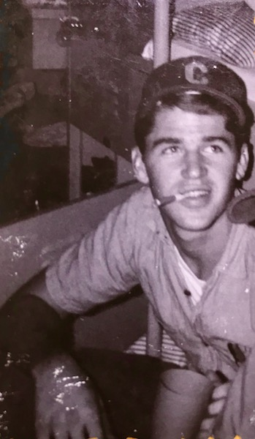

Article Six

Taps. The following shipmates have been reported as loss during this newsletter period:
QMSN Ken Lovell 72-75, LT Clayton C Hayden 77- 81, QMSN Jack D. Mayo 72-75, SK2 Bob Reese (Plank owner) 68-70

Capt. Easterling was inaccurately reported as having passed in our last newsletter. We received the inaccurate information concerning the Captain via a reported estate sale. We’re glad to report that although he resides in an assisted living facility: he’s still with us! We regret any anquish this may have caused!

If you have news of a member who has passed and has not been recognized as eternally departed at our website, please contact the webmaster at ussconcord.org.

Final Thoughts: Charleston is a great place to visit and the first time we have enjoyed our reunion in this city. If you have visited before, or perhaps you were stationed here back in the day, you know it is a history mecca as well a modern city. We tried to include the usual requested tours for your visit, but there is so much more to see as well as places to eat. With that in mind you may wish to download a couple apps to your phone to assist your stay. The main one that I use is Traveler of Charleston, you get everything from things to do, to maps, parking and even restrooms. If you plan to visit Folly Beach, I also like the Visit Folly app, which will give you all the beach stuff. I’m sure there are many more as well but you may wish to start planning now. Beyond the sites, there’s still nothing like reuniting with people with whom you served, and rehashing sea stories.

See you at the party,
Web Dude

