USS CONCORD SUMMER 2017 NEWSLETTER

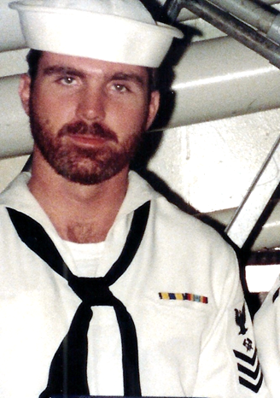

Ahoy
By Vice President \ Web Dude

Shipmates’ \ Families, “the mystery of the ships bell” has been solved. Those of you who have been with us for a while may know that I began the search for this artifact (our ship’s bell) back in 2011. At our site, you can find what I found. Fast forward to 2017 and you’ll find that Alice Daily, Vince Dekeris, and Paul Erasmus have renewed the search and not only found the bell, but the Minuteman statue and ship’s wheel. Read more about the bell and the work these folks did to ensure the legacy of these pieces of ship history, below:
Topics for this newsletter are as follows:
Article One: Membership status.
Article Two: Reunion 2018
Article Three: Ships Bell
Article Four: Member Spotlight
Article Five: Taps

Article One
Association membership remains strong with many of our original members continuing their involvement, as well as many new members signing up so far in 2017. As of this letter we currently have 133 active members on our muster.
Welcome aboard to the following shipmates who either renewed or signed up for the first time in our club since our Winter Newsletter release: Tom Hamilton (SK1 86-88), Sean Daly (Auxiliary member), Scott Daly (Auxiliary member), John Lewis (LTJG 71-74), Rodney Cooke (SM2 80-84), Steven Wagner (SK3 87-90), Arnold Thurman (MM3 74-77), Bob Toof (YN3 72-75), William Beattie (), Mike Murukis (LTJG 82-85), Ruben Maigue (SKCS 89-92)

Hopefully if you're still not a member, you’ll take the plunge and add your name to our coveted list this year!

Article Two
On Wednesday, 27 November 1968, USS Concord was commissioned at Long Beach Naval Shipyard. Fifty years later we will celebrate this event by presenting Concords 50th anniversary reunion in Charleston SC. Once again, we reached out to “A Complete Reunion” the party planners who have produced great reunion events in the past. In true fashion, these planners have already canvassed the hotels in the area and found us a good deal at the Crowne Plaza hotel and got us free breakfast for 2 thrown in with our rooms. This is a great hotel, convenient to the airport, and literally walking distance to Tanger Mall. Reunion dates have been set for 12–16 September, 2018. The hotel will begin taking reservations in September and I’ll have more details available in our Fall newsletter. Keep checking the reunion info at our website and as soon as the hotel releases the rooms, ensure you get one. Rooms will sell out!

Article Three
USS Concord ship’s bell is one of the last pieces of our ship that remains for us to cherish. Our bell held memories for me and I wanted to ensure we maintained its location for our members to enjoy. My communication with the Navy History Heritage Command, (back in 2011), allowed me to locate the bell and its location at the Washington Navy Yard. My findings were/are made available for viewing at our website. Fast-forward to 2017 and a new team took up the search for the bell, and along with the bell found the ships wheel and our Minuteman statue as well. In February Alice Daly (Auxiliary member) wrote the association stating that Vince Dekeris (BM2 68-71) had found the bell at its new location along with the wheel and statue in several different buildings at MSC HQ in Norfolk. On May 24th Alice, Vince and Paul Erasmus (BM2 68-71) traveled to Concord Massachusetts and met with Director of Veterans’ Services concerning placing our artifacts in the town for permeant display. Mr. Krug (Veterans Services Director) was very interested in obtaining these items and making them available for all to have access to view. We feel this is most fitting, to display our items in the town for which our ship was named. We are grateful to “team bell” for their work, and hopefully a dedication ceremony is in our near future, which of course will be open to all hands.

Article Four
Our association has decided to identify various members throughout the year and share their memories and pictures while serving aboard. HMC Pamela Mundling was chosen as our “spotlighted” member this quarter and her memories are available at our website, “Member spotlight” page. Here is a picture of Pam in 1992, and for more pictures of Chief Mundling and her memories while serving our ship, visit our webpage.

Article Five

Taps. Webmaster received word of passing of Charles “Chucky” Burton (SK1), and Joseph Burton but cannot find information to confirm the loss of these members. If you have information \ or served with these members please contact the association so we can officially honor them at our site.

If you have news of a member who has passed and has not been recognized as eternally departed, please contact the webmaster at ussconcord.org.

Lastly, Web dude is not an active participant in Facebook communication but did find a great Concord site for its members. If you haven’t seen what they have to offer you may wish to stop by their site and have a look “USS CONCORD(AFS5)/USNS CONCORD(T-AFS5)”. Don’t forget to regularly visit our website, however, and let’s get ready for “Reunion 2018”, where I’ll post play-by-play steps leading up to the event as it unfolds, as well as association information in general http://www.ussconcord.org/.

r,
Web Dude

