USS CONCORD SUMMER NEWSLETTER

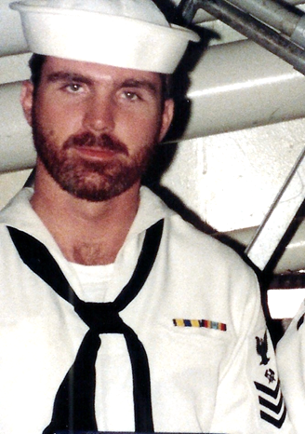

Ahoy
By Vice President \ Web Dude

Shipmates’ \ Families, we are now in the throngs of summer and unless you’re living in Antarctica you’re feeling the heat! Regardless, we hope all is well in your neck of the woods and you are braving whatever life is throwing your way. Much has happened in our association this past few months and I would like to thank those of you who keep us posted concerning news pertaining to our great ship, sea stories, and unfortunately the loss of shipmates we’ve known. Most likely the biggest piece of “Mess Deck Rumor” is the location and time of year of our 2016 reunion. It has been decided and it’s our pleasure to give you the results below. Thanks to all who participated in the reunion location survey.

Article one of this newsletter announces the survey results for reunion “2016”.

Article two is a “Ship’s Store” update.

Article three is a snapshot of membership activity both new and renewals.

Article four remembers those sailors reported as loss since our last newsletter.

Article One

2016 USS Concord Reunion Survey results: Participation in selecting next year’s reunion location was strong and we would like to report that the majority chose Norfolk Virginia as the place and September as the month for our event. Thanks to all who visited our site and placed their vote in this survey. The results are as follows:

NORFOLK | TEXAS | FLORIDA | JULY | AUGUST | SEPTEMBER
73 | 36 | 33 | 18 | 29 | 95

Once again thanks for voting and we hope to see you there. Remember that you must be a member in good standing to attend our functions so consider joining between now and next summer so you can attend, and also help us keep this association alive. Remember we are nonprofit and every penny we take in goes toward funding our operating tools and functions.

uss concord newsletter cont. | page 2

Article Two

Our Ship’s store now offers two ways to purchase cool Concord memorabilia. Our regular store at www.ussconcord.org website has the stuff you’ve seen before but has added a cool license plate frame which gives your vehicle that navy touch you’ve been looking for. (See below).

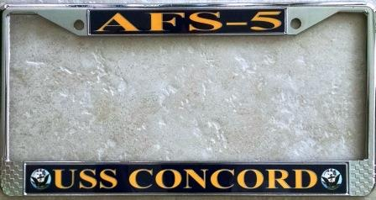

Additionally, our ships store operator Bob Smith has partnered with an online company to offer additional USS Concord "Custom apparel" products for your enjoyment. Visit http://www.mylocker.net/my/shop/uss-concord-veterans-association/index.html to shop our online store and when you find a gift you wish to purchase, a monetary percentage of your gift price will be credited to our Association so it's a win win mates :)

Article Three

Membership activity. Welcome aboard to the following shipmates who either renewed or signed up for the first time in our club:

Dennis Taylor (SK3 68-70), Michael Yamrick (DS1 72-76), Russell Miller (E-2 90-91), Eulen Moore (SK3 74-78), Brian Miller (LT 80-84), Sean Daly and Scott Daly (Auxiliary Members), Gregory McDonald (E-3 73-76), Julio Valcarcel (SKCS 78-80), Charles Arrant (CDR 86-88), Wesley Linscott (RM1 83-84), Tom Lemon (SM2 75-79), Ed Million (LT 69-71), Steven Lampp (SK3 68-72), Bruce Koon (DP3 69-71), Gary O'Neal (DP3 81-84), Bruce Butler (LCDR 71- 73).

Hopefully if you're still not a member, you’ll take the plunge and add your name to this coveted list this year!

Article Four

TAPS. Sadly we’ve received news of the passing of several Concords sailors since our last newsletter and we regret the loss of these shipmates, and feel the need to remember them……….some we knew……..some we knew of…...some who just shared that common bond of walking the decks of one of the greatest supply ships that ever sailed.

Brian P. McMahon

Brian K Gorman MMCS (SW/AW)

CDR Thomas L. "Tom" Horvatic

Keith Church (SKC 82-85)

uss concord newsletter cont. | page 3

Also it was reported that “SM2” Sanders had passed and we are looking to confirm and add him and any additional info on our website. If you have information pertaining to Sanders please contact the webmaster at our site.

If you have news of a passing member who has not been recognized as eternally departed, please contact the webmaster at ussconcord.org.

So that’s the news as of August 1, 2015. In closing I would like to extend an invitation to those who sailed Concord in her later years to register and get involved in our association and help us steer this ship into the years ahead. Regardless if you were a plank owner, or the last sailor to walk off the brow of USNS Concord you are welcome here. We will be updating the reunion page as the details unfold as to the exact day, tours, hotels etc. in the weeks to come so stay tuned to ussconcord.org.

Smooth sailing,

Web Dude

