USS CONCORD NEWSLETTER, SPRING 2019

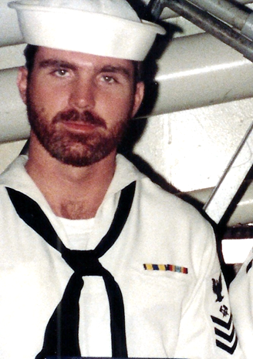

Ahoy
By Vice President \ Web Dude \ HT1 82-86
Shipmates \ Families, neither snow nor rain nor heat nor gloom of night stops the mail, but even hurricanes couldn’t prevent our 50th Concord reunion celebration! Early bird check-ins began on Wednesday 13th with the Hospitality room open and ready to receive “sea stories”. "A Complete Reunion" ensured another great reunion package and every detail from the tours to the main event “the banquet” were first class. Bob and Vicki Smith brought our ship’s store to the event and delivered an assortment of door prizes. More on the details of the party below and if you couldn’t make this reunion no worries, we will have another one in 2020 at a location yet to be decided by you. Voting is now open on our website. The choices are Nashville, New Orleans, and San Antonio! Voting closes midnight, April 10th. You must be a current member to vote!
Topics for this newsletter are as follows:
Article One: Membership status.
Article Two: Business Meeting notes
Article Three: Reunion 2019 “wash-up”
Article Four: Member Spotlight
Article Five: Taps
Article One
Association membership remains strong. As of this letter we currently have 137 active members on our muster. If you need confirmation of dues expiration, email our Secretary at garrysea@gmail.com.
We welcome new members to our organization and remind all that we are non-profit and all our proceeds go toward club functions such as our reunion event. Membership is required for those who wish to attend our reunions, but that’s not the only reason to join. By joining or renewing you’ll stay up-to-date on all association happenings (by the way it’s still only $20 bucks for two years), and gain access to the members only hatch page, which also permits access to the “members only” message board at our site.
Welcome aboard to the following shipmates who either renewed or signed up for the first time in our club since our Winter Newsletter release: Andy Dow (SK2 83-87), David Muldowney (DK2 72-75), Paul Erasmus (BM3 68-71), Allan Hale (SHB3 69-70), Joseph Caruso (RD2 71-73), Herb Taylor (CAPT 85-87), Jim Maslowski (CAPT 88-89), Carlos Mize (YN2 72-79), Kevin Ferrell (SK2 82-86), Neal White (PN3 68-69), Ed Hlusko (ET1 77-80),William Golding (BT2 72-76), Bruce Butler (LTJG 71-73), Paul Sullivan (SM1 78-81), Michael Hangelia (ET2 86-90), Tom Fox (SH3 72-75), Skip Dent (SK2 68-70), Robert Martin (EM2 71-71), Roland Rector (BMSN 74-76), Larry Murphy (LCDR 82-84), Rick Ferguson (GMG2 72-75), Bruce Koon (DP3 69-72), Robert Glover (CDR 77-79), Nick Zukerman (BTFN 75-77), Robert Beaumont (FN 68-71), Donald Luth (PN1 81-83), Dwight Roberson (GMG2 90-92), Kent Sotzing (OS2 73-76), John Lendman (DP2 68-70), John Kosicki (LTJG 69-71).
You can join or renew online here: http://www.ussconcord.org/id29.html

Article Two
Reunion 2019 Business Meeting. Garry kicked off our meeting with a brief history lesson of our club, followed by Steve with the treasurer’s report and then on to Bob’s update of the ships store inventory and his plans for the reunion raffle and lastly Geoff spoke on his CD Cruise book project (more on that below). Next, we discussed an update of our by-laws, followed by officer election nominations to carry us through our 2020 reunion. All appointed officer seats remained the same with exception of a new association chaplain. Byron Carroll (OS1 82-87) was chosen to fill the association chaplain seat and he is now included with a final thought \ prayer in each of our newsletters. We concluded our meeting with the location suggestions for our 2020 reunion. Many great locals were submitted however we hammer out 3 cities for consideration. San Antonio, Nashville and New Orleans are the cities up for vote and the winning city will be chosen by current members at our reunion website. If you have yet to cast your vote, do so at our website, reunion 2020 page, prior to midnight 10 April. Our secretary is keeping the score and will announce the winning city once it is confirmed. By the way, we voted to have the reunion September 2020 and stay on our biennial schedule.

Article Three
Reunion 2018 /19. As I’m sure you’re aware, reunion 2018 was called off due to an unexpected hurricane and was rescheduled for March 13, 2019. Tour #1 Patriots Point / Fort Sumter was a blast. We visited the USS Yorktown, had lunch in the CPO mess and concluded with a boat ride to FT Sumter. It was interesting to hear the stories as we toured the ship and more than one sailor commented on “that old ship smell”. Tour #2 Charleston Tea Plantation / Market Square / Carriage Ride was a great time as well. Saturday nights banquet was a blast and the camaraderie and sea-stories lasted well into the night. I know I say it every year but this may have been our best reunion yet!

Article Four
Our association identifies various members throughout the year and shares their memories while they served aboard. This quarter, Captain Taylor was chosen for the Spring quarter and his memories are available at our ussconcord.org website, “Member spotlight” page.

Spot lighted member
Captain Herbert Taylor

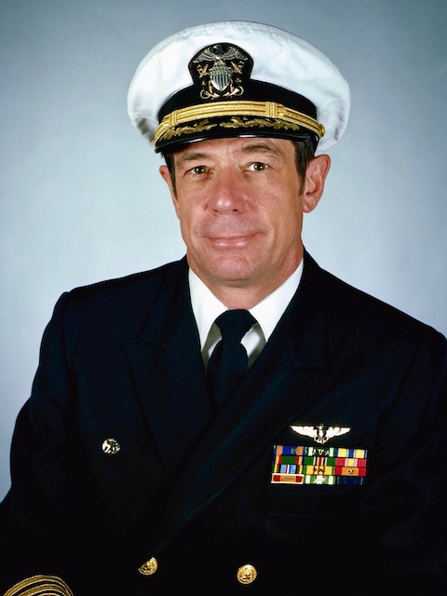

Article Five
The following shipmates have been reported as loss during this newsletter period: CDR Richard A. Buttina, SKSN Russell Terrill, Loren William Snyder, SKSC Roger Butler, Marcus Gates, AK1 Carmel Jean “C.J.” Dietz.
If you have news of a member who has passed and has not been recognized as eternally departed at our website, please contact the webmaster at ussconcord.org.

Chaplin’s thoughts: Hello Mates, I hope all is well. At the ship's reunion I saw an item in the ship's store that had with a saying that went something like this... There are good ships, and there are wood ships, the ships that sail the sea, but the best ships, are friendships, and may they always be. When all is said and done one of the most important things we have are our relationships. There is a common denominator in each of your relationships and that common denominator is you. Communication is at the heart of relationships and it is easy to have miscommunications.
Proverbs 18:20 says you will have the fruit of your mouth.
Mark 11:24 Jesus said you could ask, believe and receive.
Hebrews 11:3 says God framed the world by His word.
I believe you can be a co-creator of your world with the fruit of your mouth by saying, believing and receiving good things in every area of your life.

Heavenly Father, I pray for each of us that we would learn to say good things, believe good things and receive good things in every area of our lives. Amen

