USS CONCORD NEWSLETTER, SPRING 2018

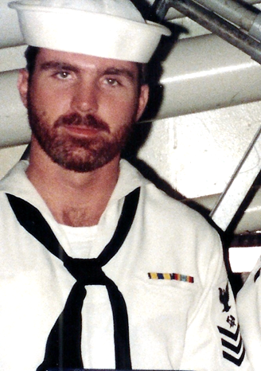

Ahoy
By Vice President \ Web Dude

Shipmates \ Families, it’s hard to believe that in only 5 months we will celebrate concords 5th biennial reunion. Turnout so far has been great and we have added additional rooms to our hotel allotment to accommodate more families. We will continue to request more rooms as long as they are available. As appropriate, the main theme of this newsletter will be the rapidly approaching reunion but we also have a few other items of importance for your perusal.

Topics for this newsletter are as follows:
Article One: Membership status.
Article Two: Reunion 2018
Article Three: Ship’s Store
Article Four: Mike Blanks “Then / Now” photo collage project
Article Five: Member Spotlight
Article Six: Taps

Article One
Association membership remains strong with many of our original members continuing their involvement as well as many new members signing up this year. As of this letter we currently have XXX active members on our muster. We welcome new members to our organization and remind all that we are non-profit and all our proceeds go toward club functions such as our reunion events. Membership is required for those who wish to attend our reunions, but that’s not the only reason to join. By joining or renewing you’ll stay up-to-date on all association happenings (by the way it’s still only 10 bucks per year to join). You can renew online here: http://www.ussconcord.org/id29.html

Welcome aboard to the following shipmates who either renewed or signed up for the first time in our club since our Winter Newsletter release: George Malvaney (Deck D-1 78-79), Richard Anderson (JO2 79-82), Steven Severance (EM3 71-73), Robert VanDerveer (MSSN 81-84), Peter Gregory (LT 90-93), Ron Gammell (SK3 68-70), Tim Sellitti (E4 85-89), Michael Phillips (EM3 82-86), Bob Edmunds (LTJG 84-86).
Hopefully if you're still not a member, you’ll decide soon to add your name to our coveted sailing list!

Article Two
On Wednesday, 27 November 1968, USS Concord was commissioned at Long Beach Naval Shipyard. Fifty years later we will celebrate this event by presenting Concords 50th anniversary reunion in Charleston SC. Once again, we reached out to “A Complete Reunion” the party planners who have produced great reunion events in the past. ACR found us a great deal at the Crowne Plaza hotel and got us free breakfast for 2 thrown in with our room. This is a great hotel, convenient to the airport, and literally walking distance to Tanger Mall, and a short ride to downtown “old Charleston”. Reunion dates are 12–16 September, 2018. The hotel is standing by to accept your reservation. Reservation activity has been high and the hotel has agreed to add another block of rooms to accommodate our event. They will continue to add rooms as long as they are available. It’s time now to make your tour selections and banquet meal signup. Visit ussconcord.org, download the reunion brochure, and print and submit pages 7&8. Page 7 guarantees you a “50th” shirt (that fits), and page 8 lets you select your meal and the tours you wish to take. The price of all tours will include a driver, gratuities, and a meal *on some tours* so this is a good deal. Each tour “must have” 35 members signed up to take place.

Article Three
Our store operator Bob, at our website “ship’s store” continues to come up with unique items for sale. He has been the driving force behind the free reunion T-shirt deal and has now procured Concord challenge coins and shot classes in addition to the other items he stocks in our store. These items will be “best sellers” and we highly recommend you stop by and place your order while they’re available. Lastly Bob always has plenty of items available in his remote display store set up at the reunion. Consider shopping our store to get some cool Concord memorabilia and help support your association. Remember we are none profit and all proceeds go to support our group functions and administrative cost.

Article Four
The following is a project that shipmate Mike Blank is working to honor our service to the Navy. Please consider sending him the requested information and let’s see what he comes up with at our reunion:
Mike writes: Members, when we were in Norfolk and took the group and individual pictures, the idea behind it was to create a collage of pics showing before and after (then and now) of all the members. I would appreciate it very much if you would send me a picture of yourself when you enlisted or sometime there around. I would prefer a boot camp pic (they were the best), but you may not have that. Try to give me the best and biggest photo you can for clarity. I prefer it digital, but will accept a scanned pic, or if you mail it to me I will make sure you get it back after I make a copy. You can mail it to me at Mike Blank, 1163 Woodland Parkway, Waynesboro PA 17268. You can send pics to my email address at mblank1163@comcast.net. If you send me something via email, do not group copy and in the subject please put your name, followed by CONCORD OLD PHOTO. I have 8 months to complete this, so your help is greatly appreciated. “Obviously, we are beyond Mike’s 8 month window so please support his project”.

Article Five
Our association identifies various members throughout the year and shares their memories and pictures while serving aboard. LTjg Mike Sheppard (78-81) was chosen as our “spotlighted” member for the Winter quarter and his memories are available at our website, “Member spotlight” page.

This month’s choice was a bit different than previous. Mike actually contributed several great sea stories in conversation at our quarterdeck page. Seeing the value of his time and adventures aboard our ship we asked Mike if he would consider being our spotlight choice and provide additional stories and information. He did, thanks Mike.
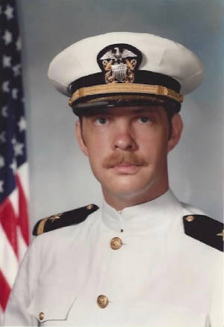

Article Six

Taps. The following shipmates have been reported as loss during this newsletter period:
SM1 Robert A. Exel, John Wallace "Wally" Clifford, Lt Barry S. Shultz (Ship's Doc early 70-72).
If you have news of a member who has passed and has not been recognized as eternally departed at our website, please contact the webmaster at ussconcord.org.

Final Thoughts: As mentioned earlier Bob has these new items available for purchase, as well as the usual classics, at our ship’s store. Click the link to our store and let Bob know how many you need. Here are pics of the new items, get them while they’re in stock. http://www.ussconcord.org/id47.html

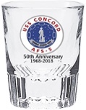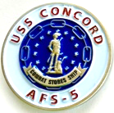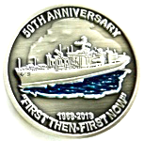

See you at the party,
Web Dude

