|  |
| --- |
| **USS CONCORD NEWSLETTER, FALL 2018** |

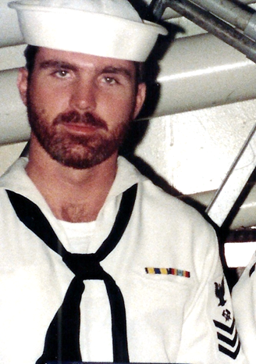

Ahoy

By Vice President \ Web Dude

Shipmates \ Families,

Topics for this newsletter are as follows:

Article One: Membership status.

Article Two: Reunion 2018

Article Three: Ships Store News

Article Four: Member Spotlight

Article Five: Taps

*Article One*

Association membership remains strong with many of our original members continuing their involvement as well as many new members signing up this year. As of this letter we currently have 151 active members on our muster. We welcome new members to our organization and remind all that we are non-profit and all our proceeds go toward club functions such as our reunion event. Membership is required for those who wish to attend our reunions, but that’s not the only reason to join. By joining or renewing you’ll stay up-to-date on all association happenings (by the way it’s still only $20 bucks for two years), and gain access to the members only hatch page, which also permits access to the “members only” message board at our site. You can join or renew online here: <http://www.ussconcord.org/id29.html> AS A BONUS, THE BALANCE OF 2018 HAS BEEN WAIVED FOR NEW MEMBERS SO YOUR $20 MEMBERSHIP WILL COVER YOU THROUGH 2020!

Welcome aboard to the following shipmates who either renewed or signed up for the first time in our club since our Summer Newsletter release: ***Charles Fletcher (SM3 69-70), Jim Evans (SM3 68-70), Glenn Flint (MM2 89-89), Robert Sharp (LTJG 72-75), Larry Trotter (QM2 69-72), Ed Million (LT 69-71), Garry Collins (LTJG 81-84), Harold Noel (LTjg 78-81), Frank Sprada (MM3 68-70), William Willis (SN 68-70), Harold Byers (LCDR 85-88), John Regina (OS3 73-75).***

*Article Two*

Reunion 2018, September 12-16th in Charleston S.C. was unfortunately cancelled due to Hurricane Florence. This was touted to be our largest gathering as of yet with well over 100 sailors and guest signed up to attend. Fortunately, Flo made her intentions early enough to allow for cancellations and prevent too much disruption in travel arrangements. I know some of you were already in motion and hopefully you weren’t too disrupted by this cancellation and will once again plan your trip as soon as signup begins. Reunion 2018 has been rescheduled for March 13, 2019 with the banquet on Saturday night the 16th, at the same hotel as previously planned. Tours itinerary is undecided at this time. The exact details and signup commencement will soon be decided and an all hands email will follow so you may plan your visit. Our 2020 reunion will stay on track and we can decide its location at our March 2019 business meeting. Hopefully the sting of Florence will be in the distant past and once again you’ll signup to celebrate 50 years of Concords service.

*Article Three*

Ship’s store news: Our ships store operator has been operating overtime to ensure you have the latest and greatest Concord items possible. Bob and his wife worked tirelessly to provide shirts and door prizes for our reunion and unfortunately all was placed on hold. At this time Bob is standing by to do a repeat in March. At that time, if you had previously ordered a shirt through your September reunion signup, your shirt will be handed to you at the March reunion check-in procedure. If you are unable to attend he will deliver your shirt after the March date via mail. If you attend the March reunion (but weren’t registered for the original reunion) and would like a shirt, Bob should have a few extra shirts on hand and you can purchase one of those, first come, first served. If all the extra shirts are sold, Bob will do one special order after the reunion for reunion attendees only. The cost will be $20/shirt (includes shipping). Lastly, remember we have many cool items that you can order from our store right now……so please visit and support your association <http://www.ussconcord.org/id47.html>.

*Article Four*

Our association identifies various members throughout the year and shares their memories and pictures while serving aboard. This quarter we chose two members, Radiomen George and Jon Fuller for the Summer quarter and their memories are available at our website, “Member spotlight” page.

***Did you know that in 1969 - 1970 Concord was home to identical twins George and Jon Fuller. Pretty cool huh so we chose them as this quarters "Spot lighted Members". See them below with their cool 1949 Ford, and check out their story at the "Spot Lighted Members" page at our website.***

George also sent us a great sea story a couple year back so be sure and read his comments at our “sea stories” page also. It further details the events of true brothers at sea……

George on the left, Jon on the right.

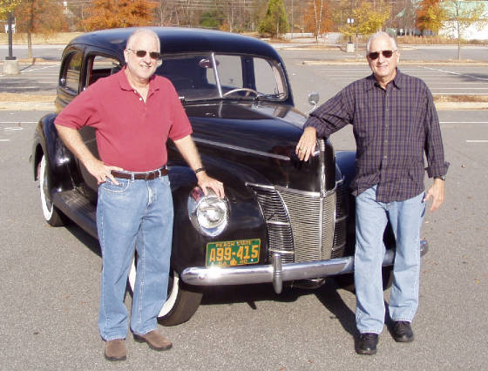

*Article Five*

The following shipmates have been reported as loss during this newsletter period: *BMSN William Jones 91-93, MS3 Alvoid Brown, Capt. Casimir E Sojka 73-74.*

If you have news of a member who has passed and has not been recognized as eternally departed at our website, please contact the webmaster at ussconcord.org.

Final Thoughts: I, as well as many of you, had high expectations for the summer event and was eagerly looking forward to a great reunion with Concord shipmates and friends. As the days grew closer to the event I watched the weather report daily if not hourly hoping that the storm would take another path. Unfortunately, it did not but as the storm made its statement on the coast it was refreshing to read members memories of past Concord hurricanes, at our Face Book page, and how they and their families reacted. I was on Concord during Hurricane Gloria. We were stranded in the shipyard, and a skeleton crew was assigned to weather the storm. It was an exciting night to say the least and a memory that has stayed with me and was relived during this event. It was also refreshing to read the written support by some of our members concerning shipmates who were affected by the storm. This reinforces the need for us to continue our camaraderie through reunions, and electronic communication. I hope you have decided to be present at the reunion in March, and this may very well turn out to be our best reunion event thus far.

See you there,

Web Dude