USS CONCORD FALL 2016 NEWSLETTER

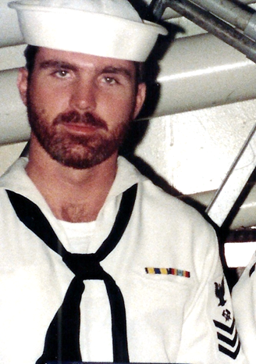

Ahoy
By Vice President \ Web Dude

Shipmates’ \ Families, USS Concord reunion 2016 was a blast. Early bird check-ins began on Wednesday September 7th for those taking the Williamsburg & Jamestown tour. Many of our regular attendees saw fit to make the journey again this year as well as many “first timers” in attendance. Steve Larsen (association treasurer) and the good folks at "A Complete Reunion" ensured great accommodations and every detail from the tours to the main event “the banquet” were first class. Bob Smith, and his wife Vicki brought our ship’s store to the event and delivered an assortment of door prizes at the banquet. I can’t say for sure if it was the ambience, re-acquaintance of old shipmates, or the open-bar but all in attendance had a good time! If you missed this reunion no worries, we will party again in 2018 at a location yet to be decided.
Topics for this newsletter are as follows:
Article One: Membership status.
Article Two: Business Meeting notes
Article Three: Reunion 2016 “Wash-up”.
Article Four: Black Friday sale
Article Five: TAPs.

Article One
Association membership remains strong with many of our original members continuing their involvement, as well as many new members signing up this year. As of this letter we currently have 142 active members on our muster. We welcome new members to our organization and remind all that we are non-profit and all our proceeds go toward club functions such as our reunions. Membership is required for those who wish to attend our reunion events, but that’s not the only reason to join. By joining or renewing you’ll stay up-to-date on all association happenings and receive your very own membership card etc. (by the way it’s still only 10 bucks per year to join and if you join, or re-up now your membership will be good throughout 2018).

Welcome aboard to the following shipmates who either renewed or signed up for the first time in our club since our Summer newsletter release: Matt Daigle (MM2 86-91), Ben Ellis (BT2 68-71), Tom Fox (SH# 72-75), KD Jeter (BTC 72-85), Mike Murukis (LTJG 82-85), Mike Neeser (DC2 68-71), Troy Smith (EM# 86-90), Scott Wood (DC2 87-91), Robert Sharp (LTJG 72-75), Robert Beaumont (FN 68-71), Harold Noel (LTjg 79-81), Gary Jardine (BT2 70-73), Steven Severance (EM3 71-73). Frank Sprada (MM3 68-72), Tom Robey (RM3 83-86).
Hopefully if you're still not a member, you’ll take the plunge and add your name to our coveted list this year!

Article Two
Our biennial Business meeting was held on Saturday morning and was a great show of comaraderie and information. Club president Tom Weber presided over the event and Secretary Garry Collins recorded notes and generally kept the crew focused and on time. Garry originally recommended a one hour max (which would allow the folks attending the air show time to make the event) and he pretty much kept us within that time frame. Much jovial bantering and bickering throughout the BM allowed for a positive event and the following decisions \ outcome was decided:

- There were two By-Law changes: one to correct nomenclature in Section 2, Line 2 to “combat stores ship” from “refrigerated stores ship”. Members voted unanimously to accept the change. Article VI, Section 2 was changed to read “Members present at the business meeting may select the next reunion city by vote or members present may decide to select two or three cities for consideration and open the voting process to all CVA members at a future date”. Members voted to accept the change.
- Per the newly modified By-Laws, members present voted to allow the entire CVA membership to select from three nominated cites. The following three cities were nominated and voted on by all CVA members:
- Three cities were chosen for consideration as the location for the 2018 reunion: New Orleans, San Antonio, and Charleston SC. Tom Weber will gather information on San Antonio, Geoff Easter will gather information on New Orleans, Bob Smith will gather information on Charleston.

Article Three
Reunion 2016, September 8-11th in Norfolk Virginia was one of our best yet. "A Complete Reunion", hosted our event and every day was filled with fun and fellowship. Guest were greeted with information / attendee packages and directed to “hangout” in the hospitality suite. The hospitality suite became a gathering place in-between tours and meetings and was a huge part of the reunion. Shipmates were transported back to their time on board and sea stories flowed as did the beverages. Sheraton Waterside hotel thoroughly provided all amenities including the banquet on Saturday night. Each day featured a different tour event and the weather was perfect.
Saturday morning, we enjoyed a very productive business meeting and it was decided that all officers had done enough to be allowed to hold their positions again for the next two years. All voted unanimously except the officer being nominated . The evenings banquet kicked off with meet and greet time and guest frequented the bar and reacquainted themselves at each table. Association President Tom Weber took to the podium and welcomed guest and presented the night’s event. Guest were asked to stand as Tom delivered the “Two Bell” ceremony to pay honor to those Concord sailors who were reported as eternally departed since our last reunion. Club Secretary Garry Collins followed next with a reading of the poem (40 Years Gone) which is available at our website under the poems tab. A special tribute was offered to the missing man, and Garry offered an invocation blessing for our meal. The food was served and the crowd quieted as the tables enjoyed the food and drink. Throughout the evening pictures were taken of guest and groups and finished with awarding many lucky guest with door prizes to take home. Reunion pictures are posted at our website under the “reunion tab”.
Sunday morning, we loitered around in the lobby planning our departure back home. Handshakes and nods said “see you at the next one” as guest left out one by one.
If you were not present, you missed a good one but no worries we’ll do it again in 2018. Keep checking our website and early 2017 we’ll start soliciting your input for your next reunion location.
USS CONCORD PLANKOWNERS

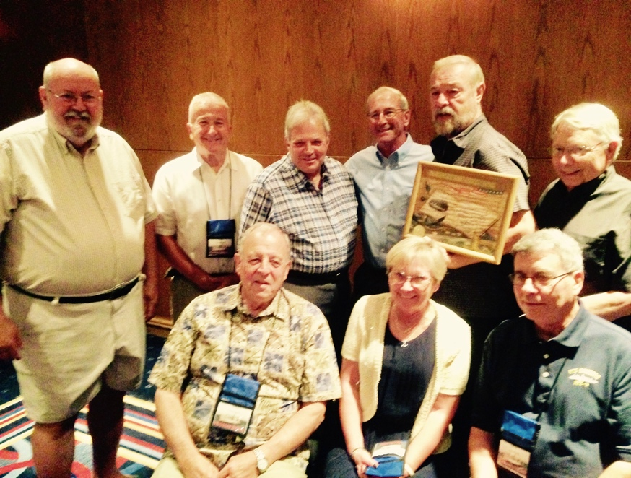
Article Four
Black Friday sale at the USS Concord store is now happening! In celebration of our 8th year in existence, our ship’s store operator has decided to give back to our members some fantastic deals. From the date of this newsletter through Thanksgiving you can purchase select Concord shirts at half price. This is an amazing deal for our members and will definitely help with early Christmas presents. Make your purchases now and the sale will last until all sale items are gone or the Thanksgiving day rolls around.

Article Five
TAPS. Sadly, we’ve received news of the passing of a Concord sailor since our last newsletter. We regret the loss of our shipmates, and feel the need to remember them………. some we knew……. some we knew of…...some who just shared that common bond of walking the decks of one of the greatest supply ships that ever sailed.

Dean L. Troutman (E-6 70’S – 81)

If you have news of a member who has passed and has not been recognized as eternally departed, please contact the webmaster at ussconcord.org.

Our association is now in its 8th year and going strong. Garry Collins and Ben Barresi laid the foundation and signed our sailing list on 1/Jan/08, and by the end of that first year USS Concord association comprised of 20 members. Fast forward to today and I’m pleased to announce we number 142 active members. Our 4th biennial reunion in September confirmed the solidarity among Concord shipmates and the need to continue celebrating our ship. Our reunion 2018 will be special in that we will be celebrating USS Concords 50th anniversary. As earlier mentioned, you will help select where we host this special event and I hope you will make a commitment now to be part of this celebration.

Lastly, don’t forget to visit the store, and remember every penny you spend goes directly back into our club and its functions: http://www.ussconcord.org/id47.html

r,
Web Dude

