USS CONCORD SPRING NEWSLETTER

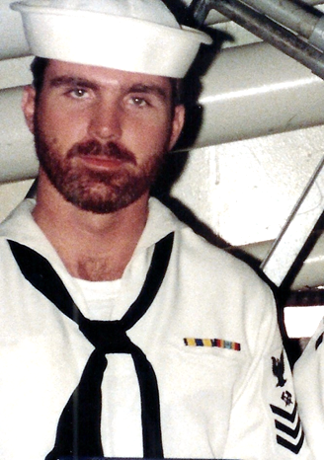

Ahoy
By Vice President \ Web Dude

Shipmates \ Families, the freezing weather has now passed and it’s time to get the gardens blooming, prepare for the long anticipated summer vacations and of course clean-up and light off the grill. I don’t know if it’s just me and my advancement through the years but it seems this past winter just kept going and going? Regardless we made it, and it’s time to welcome summer. As you make your summer plans I would ask you to pause this Memorial Day 2015, and reflect on our amazing freedoms and remember the men and women who sacrificed to make that it a reality.

Article one of this newsletter is a brief reflection on our last “2014” Club reunion in Louisville Ky.

Article two explains the upcoming reunion “2016” and how you can help decide where it is to be held and time of year for the event.

Article three is a snapshot of membership activity both new and re-newals .

Article four remembers those sailors we loss during this past year.

Article One

Reunion 2014 in Louisville Kentucky proved to be just what a bunch of crusty old sailors needed. Toasting each other, telling sea stories and relating how our lives have journeyed since we set sail in the civilian world.
Our club Secretary Garry Collins represented the great state of Kentucky and I have to say he went all out! Everything from horses to baseball bats was available and the night life leading up to our banquet dinner was first class. We had a productive member meeting Saturday morning where we ironed out association business and laid the groundwork for where we think the club should head and milestones to be met in 2015-16. If you couldn't make it in 2014 no worries, we’ll have another in 2016 and you're welcome to be a part of it. Hope you decide to come out!!

uss concord newsletter cont. | page 2

Article Two

Reunion 2016 is only about 15 months out and we are beginning the process of site selection, and when to hold the event. As in the past we put it to the crew to send us suggestions (of the three venues narrowed down) as to where they preferred the event to be held and what time of the year best suited them. A survey will be placed on our website in June that will allow you to see what is offered and place your vote. I would encourage all hands to get in on the action, whether you’re an active member or not, and help us decide our future location. If you've never attended one of these reunion functions I encourage you to give it a try, and if you're a returning member you know we have fun. Here are the locations that will be available for selection:

- Norfolk Virginia. This was our first reunion back in July 2010. The folks who organized the event really went all out to ensure we had a good time. I don’t know if it was the “old Pier 4” still in our blood or not but this was our biggest reunion to date.
- Panama City Beach (sponsored by shipmate Rick Cline). He recommends the Wyndham Bay Point Resort in Panama City Beach. Not sure of all the goodies here but am sure Rick can fill us in on the details which I’ll post on our site at selection time.
- Lastly we have San Antonio Texas as choice number three. Not sure what all we can get into there but we will have more information as June approaches.

Please consider the above sites and help us keep the memories of a great ship and great crew alive! Lastly, while you can vote on the reunion location, you must be a member in good standing to attend. Please consider joining between now and next summer so you can attend, and also help us keep this association alive. Remember we are nonprofit and every penny we take in goes toward funding our memories and functions.

Article Three

Membership drive has been strong this past year 14-15 and the following shipmates either renewed or signed up the first time in our club:

Dennis Dee (ADR-3 / "HC-6 Det-86" 70-71), Michael Blank (BMSN 74-75), Arnold Thurman (MMFN/E-4 74-77), Richard Mayo (RM3 72-75), Norman Wheeler (ETN3 71-74), Robert Texiere (SK3 73-75), Marty Miller (HT1 82-84), Bill Matterazzo (EM2 70-73), Edward Hlusko (ET1 77-80), Herb Taylor (CAPT 85-87), Mike Bozek (BM2 68-70), Steve Larsen (DP2 68-70), Alan Wisniewski (GMG2 70-73), Gary Jardine (BT2 70-73), Rick Ferguson (GMG2 72-75), Dennis Romo (FTG3 72-74), Buck Slater (YN3 72-75), Steve Britt (BT3 67-69), Kent Sotzing (OS2 73-76), Rodney Cooke (SM2 80-84),
LeRoy Graf (GMG3 70-72), Rondal Adkins (BMSN 80-84), Allan Hale (SHB3 69-70), David Naugler (EM3 81-85), Herbert Stephan (CDR 87-89), Larry Weill (LT 82-86), David Stascak (SN 69-70), John Kosicki (LTJG 69-71), John Leindecker (CWO4 \ Air Det), Gary Rubbert (DP2 82-84), Lenn McMillian (IC3 71-74) Bob Smith (SH2 68-70), Bill Brown (GMG2 72-76), Lee Daley (CS1 68-69), Neil Westgate (BT2 70-73), Danny Gatchell (GMG3 68-70), Len Lewis (EM2 68-70), Henry Dye (SN 68-68), Gordon Hillesland (GMG3 68-70), Bob Boykin (GMG3 68-70), Larry Baun (LT 80-83), Byron Carroll (OS1\ SW 82-87), Steven Severance (EM3 71-73), Tom Weber (BT2 85-90), Rick Cline (DC3 91-92), George Fuller (RM2 69-71), Gary Lyon (SN 70-73).

Hopefully if you're still not a member, you’ll take the plunge and add your name to this coveted list this year!

uss concord newsletter cont. | page 3

Article Four

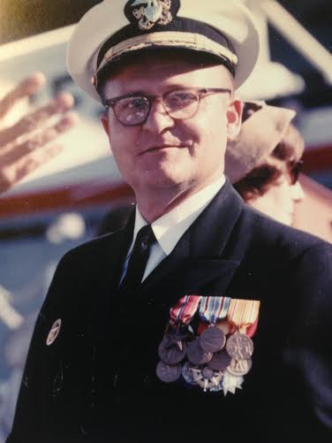
TAPS. Unfortunately we’ve received news of the passing of some of Concords sailors during this past year and we regret the loss of these shipmates, and feel the need to remember them……….some we knew……..some we knew of…...some who just shared that common bond of walking the decks of one of the greatest supply ships that ever sailed.

USS Concord’s first Commanding Officer Louis J. Collister passed away on August 17th , 2014. He was 91 years old.
A note from his daughter: “I remember the Commissioning of the Concord, and I believe that it was one of my father's happiest memories. I, of course, loved every ship that carried him. I trusted each to bring him safely home to his family. The Concord was special. I saw her come to life. The pennants ran up, she bellowed her presence, and her power made the seas part before her. I thought she was beautiful.

Now, both are at their final berth, and I wish you all fair winds, and mild seas. It has been a proud run.

Kathryn Collister”

BM2 James Michael 'Mickey' Hurlburt Sr
SHS3 Michael W Rucker (86-89)
Ricky Eugene Rice (68-71) photos attached.
Terry Bolton (1968-1971)
SKSN James Gollinger
EN2 Binnie Knudson (Plankowner)
MS3 Patrick H. Faircloth Jr. 81-85
DPC Eugene "Gene" Harold Stanton
SKSN John Trendler 68-70 "Plankowner"

If you have news of a passing member who has not been recognized as eternally departed, please contact the webmaster at ussconcord.org.

