USS CONCORD SPRING NEWSLETTER

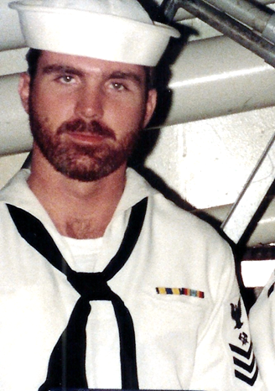

Ahoy
By Vice President \ Web Dude

Shipmates’ \ Families, welcome sweet spring time. Hopefully you’ve made it through the winter weather and ready for some much needed cool nights and warm days. As of this letter, we are about 5 months away from our Concord reunion and I hope you are at least considering attending. Some members of our association have already signed up to attend, and if your still sitting on the fence I recommend you go ahead and make the decision to be at this one. We are fortunate to have the same party planners coordinate this function, which organized and presented our first reunion back in 2010. It was a blast, and I expect that and more this year. Hope you plan on coming, and we’ll see you there.

Topics for this newsletter are as follows:
Article One: Membership status.
Article Two: New store items.
Article Three: Reunion 2016.
Article Four: TAPs.

Article One
Association membership remains strong with many of our original members continuing their involvement, as well as many new members signing up this year. As of this letter we currently have122 active members on our muster. We welcome new members to our organization and remind all that we are non-profit and all our proceeds go toward club functions such as our reunions. Membership is required for those who wish to attend our reunions, and receive membership cards etc. (by the way it’s still only 10 bucks per year to join).

Welcome aboard to the following shipmates who either renewed or signed up for the first time in our club since our winter newsletter release:
Ruben Maigue (?), Fredrick Keith (LT 71-74), Carlos Mize (YN2 72-79), Pamela Mundling (HMC 91-92), Silas Dalrymple (83-86), Tom Weber (BT2 85-90), John Regina (OS3 73-75), William Furlong (EN2 71-73), Kenneth McMillen (LT 69-71), Robert Cherry (MS1 80-83), Daniel Tanzosh (GMG3 68-70), William Shaw (SHSN 91-92), Robert VanDerveer (MSSN 82-84), Scott Eckhart (BM3 82-85), Barry Cravens (SK3 83-87), Nick Kormylo (CS2 68-70), Stephen Anderson (RM2 68-71), Robert Glover (CDR 77-79), Chris Parente (LT 79-82), George Trbovich (CAPT 80-82), David Muldowney (DK3 72-75), Byron Carrol (OS1 82-87), Frank Korzeniewski (RM3 72-74), Jerome Kandziorski (RD2 68-70), Michael Wehrle (EM2 70-72), Gary Lyon (SN 70-73), Nick Zuckerman (BTFN 75-77), Geoff Easter (LT 79-81),Paul Parker (DP3 68-70), Donald Luth (PN1 81-83).

Hopefully if you're still not a member, you’ll take the plunge and add your name to our coveted list this year!

USS concord newsletter cont. | page 2

Article Two

Our Ship’s store operator has placed several new items in our store, such as the beautiful mugs (See below). We also have shirts with this design, and if you sign up to attend our upcoming reunion, we’ll throw in a free one for each attendee, just tell us what size you need on your registration form.

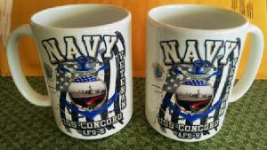

Visit the ships store http://www.ussconcord.org/id47.html.

Article Three

Reunion 2016 has been set for September 8-11th 2016 in Norfolk Virginia, so get ready for a great time. We are pleased to have the good folks at, "A Complete Reunion", host our 2016 event. This is the team that organized our first reunion back in 2010 and it was a blast! Reunion events will begin with tours and shopping, members’ business meeting Saturday morning, and ultimately lead up to the main event, the banquet, on Saturday night. Our banquet and lodging will be at the Sheraton Waterside Norfolk. I highly recommend that you plan your visit now, and via our website link www.ussconcord.org/id150.html download the brochure, sign up and reserve your room soon, and don’t forget to tell us what size shirt’(s) you’d like. If you are not yet a member head on over to our website and join so you can attend this event.

Contact Sherry or Jessica at 719-380-1412 for questions concerning this event.

Article Four

TAPS. Sadly we’ve received news of the passing of several Concords sailors since our last newsletter and we regret the loss of these shipmates, and feel the need to remember them……….some we knew……..some we knew of…...some who just shared that common bond of walking the decks of one of the greatest supply ships that ever sailed.

Thomas Truskowski SKSN 68-71

Randall Dacatur CSC 73-75

Sam Harrison 85-89

If you have news of a member who has passed and has not been recognized as eternally departed, please contact the webmaster at ussconcord.org.

Web Dude

